**A GUIDE TO DOWNLOAD**



**FILES FROM GOOGLE DRIVE**

**WITH OAUTH 2.0**

**USING A**

**SERVICE ACCOUNT KEY**

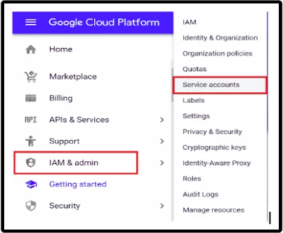

THIS GUIDE WILL WALK YOU THROUGH THE PROCESS OF DOWNLOADING A FILE FROM GOOGLE DRIVE USING A SERVICE ACCOUNT KEY.

A SERVICE ACCOUNT IS A GOOGLE ACCOUNT THAT

REPRESENTS YOUR APPLICATION INSTEAD OF AN



INDIVIDUAL USER. IT ALLOWS YOUR APPLICATION TO ACCESS GOOGLE APIS ON ITS OWN BEHALF.

PLEASE FOLLOW THESE STEPS TO ACHIEVE THE FILE DOWNLOAD

# 

# **STEP 01:**

**Set up a Service Account and Enable the Google Drive API**

1.Go to the [Google Cloud Console](https://console.cloud.google.com/).

2.Create a new project or select an existing one.

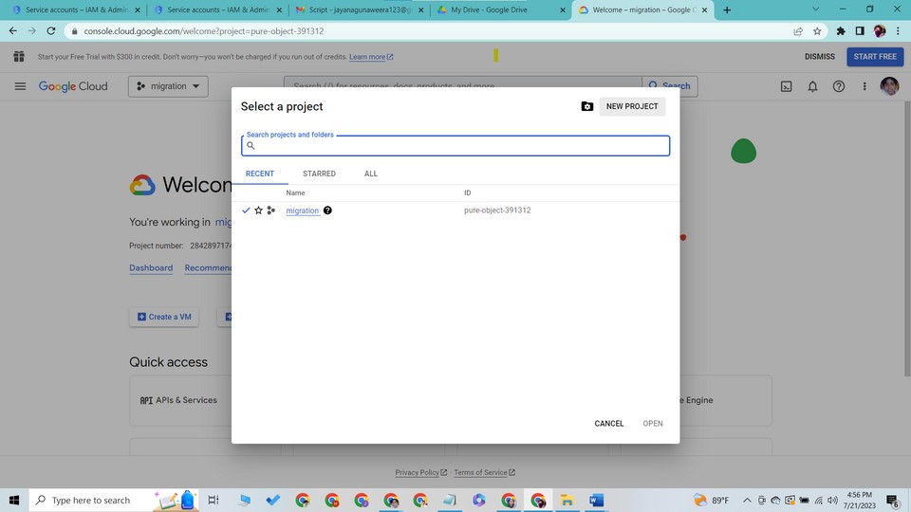

3.In the left sidebar, click on "APIs & Services" > "Dashboard."

4.Click on the "+ ENABLE APIS AND SERVICES" button.

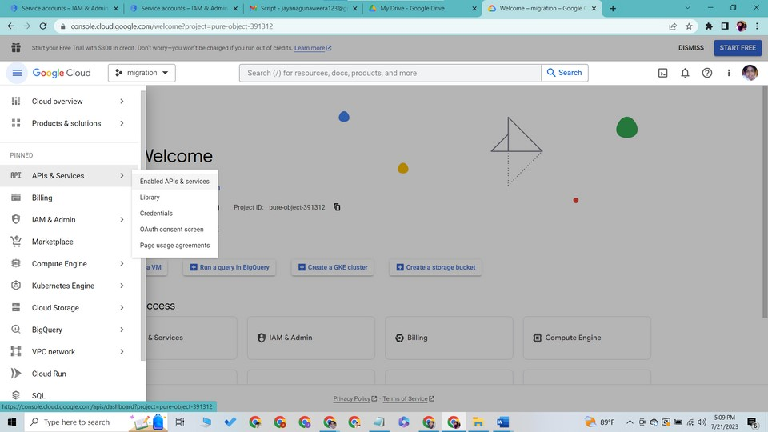

5. Search for "Google Drive API" and select it.

6.Click on the "ENABLE" button to enable the API for your project.

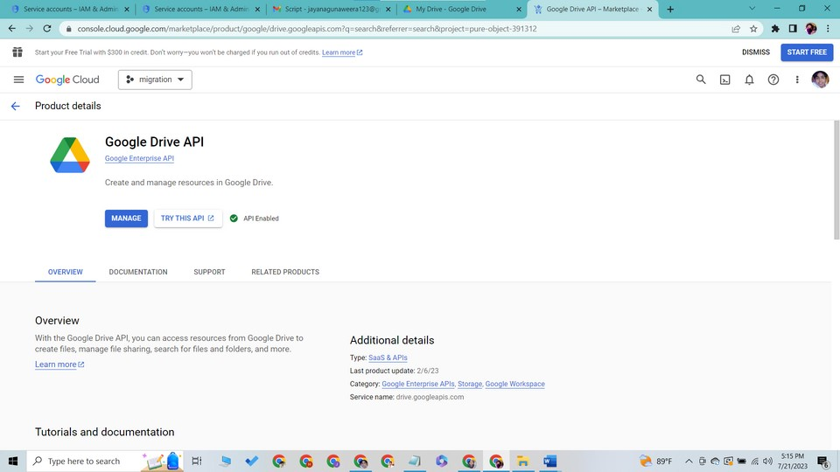

# **STEP 02:**

**Create a Service Account and Obtain the Key:**

1.In the left sidebar, click on "APIs & Services" > "Credentials."

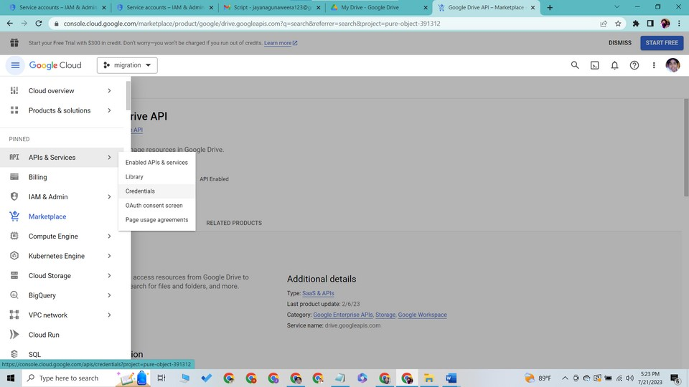

2.Click on the "+ CREATE CREDENTIALS" >"Service account."

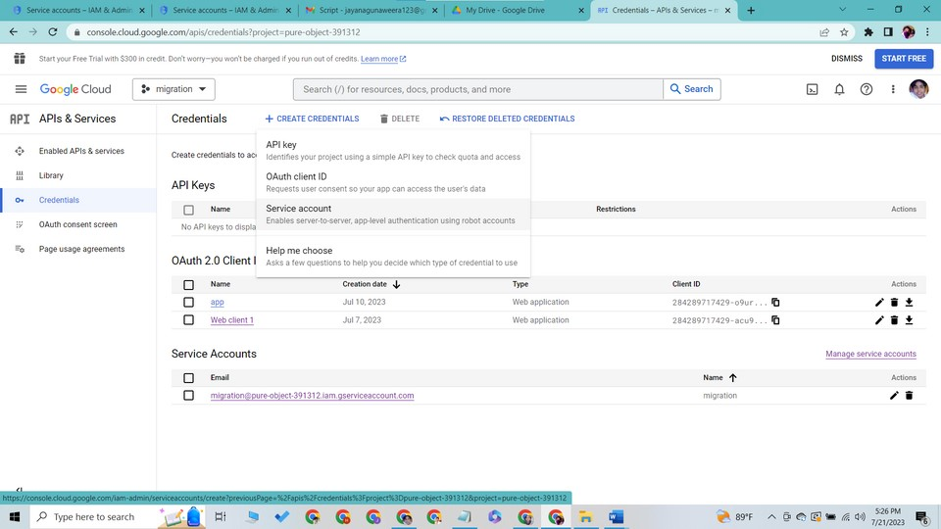

3.Enter a name for the service account,thus a service account ID will be

automatically created.

4.Click create and continue.

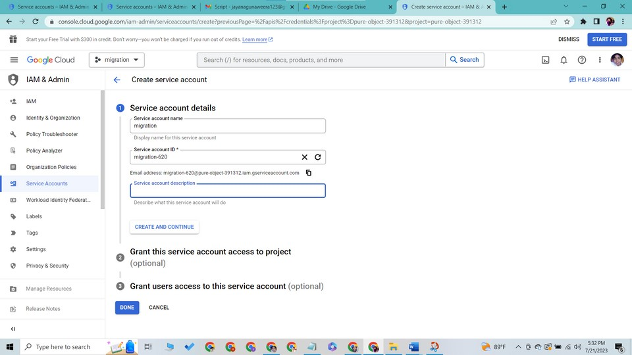

5.Grant this service account access to project as owner

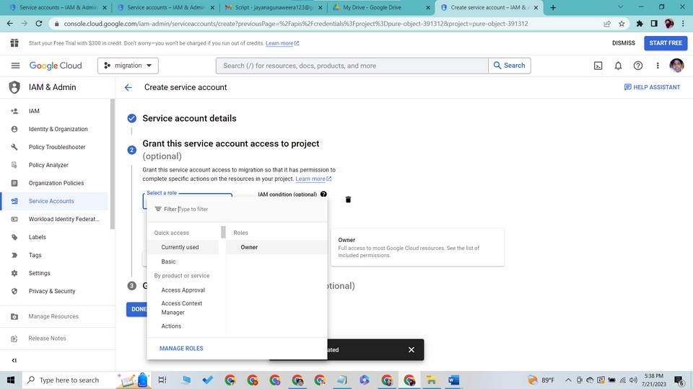

6.Click continue. You will see a message showing policy has been updated.

Then click done.

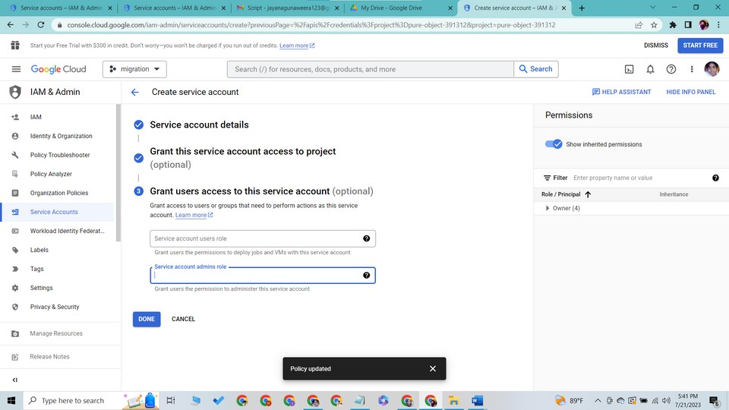

7.In the left sidebar, click on IAM and Admin and select "Service account. “

You will be able to see the newly created email address for the service

account.

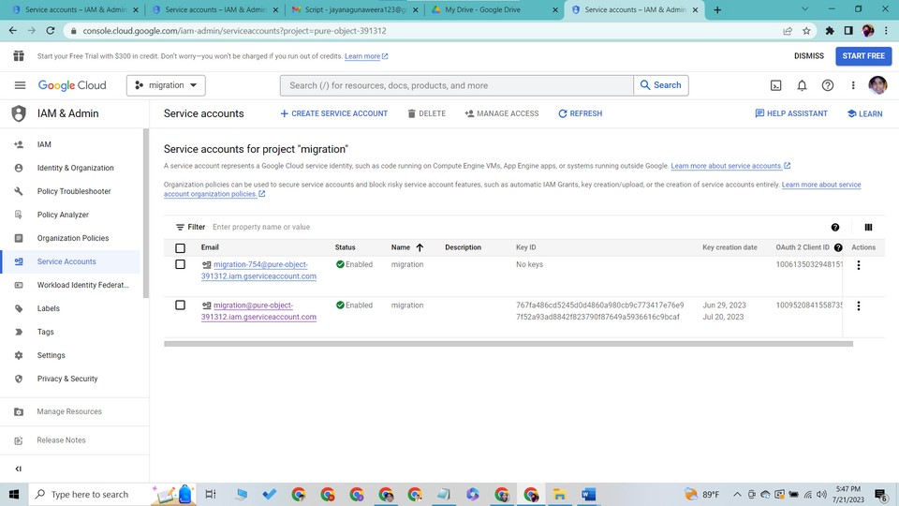

8.Click on the newly created email address and select "Keys" tab.

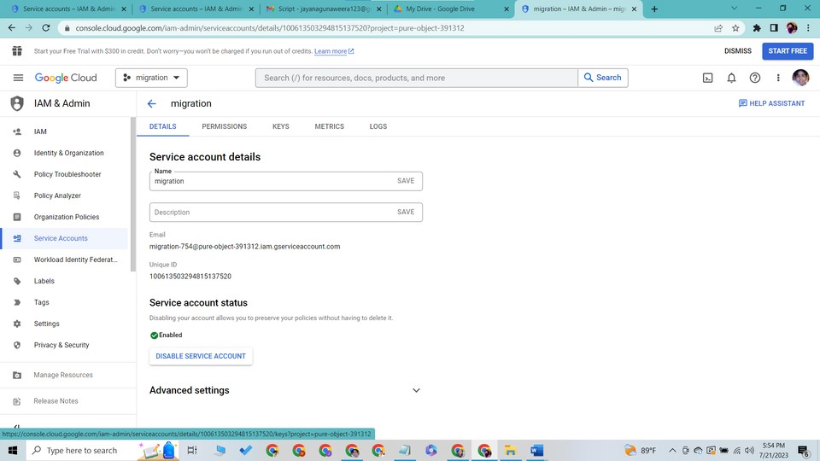

9.Click "add key" > "create a new key"

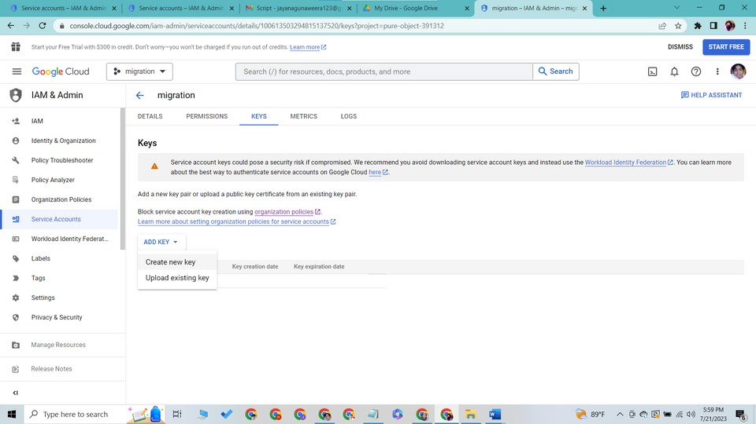

10.Select "JSON" as the key type and click on the "CREATE" button

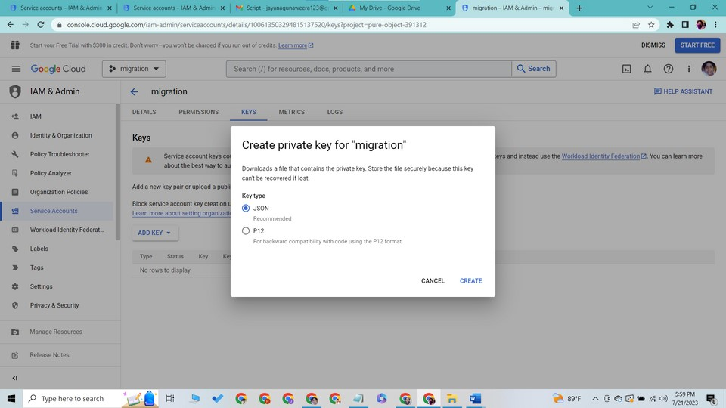

11.The JSON key file will be downloaded to your local machine.

**Keep this file secure, as it provides access to your Google Drive.**

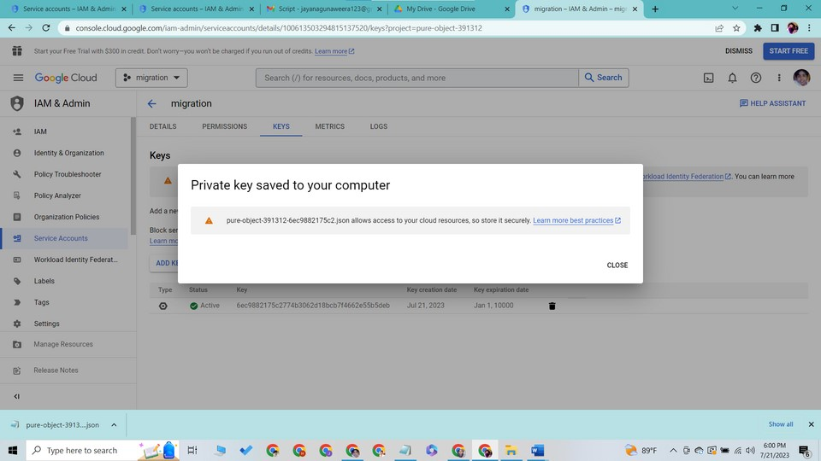

# **STEP 03:**

**Grant Access to the Service Account in** **Google Drive:**

1.Open your Google Drive.

2.Locate the file you want to download and right-click on it.

3.Click on "Share."

4.In the sharing settings, enter the email address associated with your

Service Account (can be found in the JSON key file).

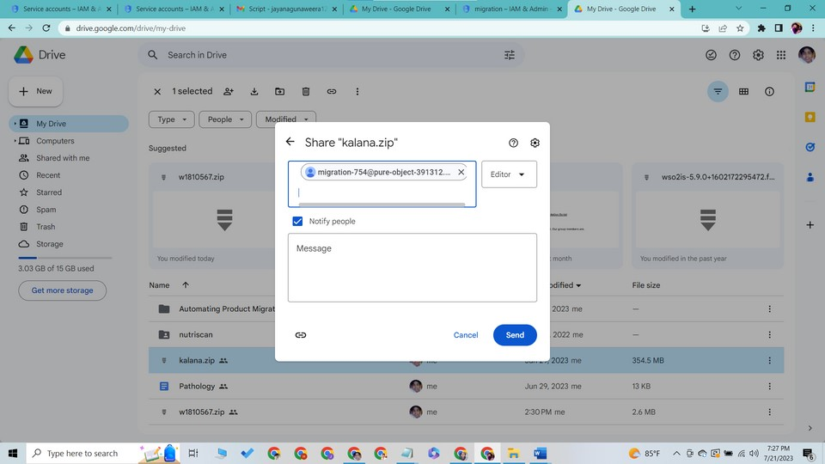

# 

# **STEP 04:**

**Download the File using the Service** **Account Key:**

Now, let's download the file using the Service Account Key from your application code or any programming language of your choice (e.g., Python)

**Click Below Link To Access Python Script** **To Download GA Packs** [Shell script to download a drive file using a service account key - Google Docs](https://docs.google.com/document/d/1iR5u9Tjglvd_WErd6IzrmsPlMICeAjUVCOlp3nbZz6I/edit)

Replace **path/to/your/service-account-key.json** with actual path to

your Service Account key JSON file.

FILE_ID with the ID of the file you want to download (can be found in file URL).

**How to get the file ID of a file?**

To get the file ID of a file in Google Drive, follow these steps:

1.Open Google Drive: Go to <https://drive.google.com/>and sign in with your Google account.

2.Locate the File: Navigate to the file for which you want to get the file ID.

3.Get File Info: Right-click on the file and select "Get link" from the context menu.

4.Obtain File ID: In the link that appears, the file ID is located after the "/file/d/" part and before any other parameters or slashes. For example, if the link is "[https://drive.google.com/file/d/abcdefg1234567/view"](https://drive.google.com/file/d/abcdefg1234567/view), the file ID is "abcdefg1234567".

That's it!

Now you have successfully obtained the file ID of the file in GDrive.

You can use this file ID in your scripts or applications to interact with

specific file using the Google Drive API.

**LET'S BREAK DOWN THE STEPS OF THE** **SHELL SCRIPT**

|  |  |  |
| --- | --- | --- |
| **Generating a JSON Web Token (JWT)**  The script proceeds to generate a JSON Web Token (JWT). The JWT will contain specific claims such as issuer (service account email), scope, audience, expiration time, and issued at time. These claims are combined into a request body and signed using the private key associated with the service account. | **Requesting an Access Token**  With the signed JWT ready, the script constructs a POST request to the Google OAuth 2.0 endpoint to request an access token. The request includes the signed JWT in the request body. This request is made using the **curl** command to communicate with the OAuth server. | **Extracting the**  **Access Token**  The response from the OAuth server is captured and stored in the **token_response** variable. Thescript then extracts the access token from the **token_response** using the **jq** command and stores it in the **access_token** variable. |

04

04

## Downloading the File from Google Drive

The script specifies the Google Drive file's URL that needs to be downloaded. It includes the **access_token** in the request headers as an Authorization Bearer token. The **curl** command is used again, this

05

06

01

02

03

time to download the file from Google Drive.

## Handling the Response

The script checks if the response contains any error message by looking for the presence of **"error":** in the response. If there is an error, it prints a failure message with the error description. Otherwise, it prints a

success message indicating that the file was downloaded successfully.

### Unzipping the Downloaded File

If the file was successfully downloaded, the script proceeds to unzip the downloaded ZIP file using the **unzip** command.

**DISCLAIMER!**

Using the above method to access Google Drive files through a service account and obtaining file IDs comes with certain risks. Some of the potential risks include:

**Service Account Security:**Failure to adequately secure the service account's private key

or credentials could potentially lead to unauthorized access by maliciousactors.Note that

private keys generate from service accounts never expire.

**API Changes and Deprecation:**Google may change or deprecate the Google Drive API, affecting thefunctionality of the script and requiring updates to keep it functional.

**Rate Limiting:**The Google Drive API imposes rate limits on the number of requests per day, which, if exceeded, may result in temporary service disruptions.

e

n

d



The content of this document is an intellectual property of the WSO2 IAM Team.

COPYRIGHT © 2023 WSO2 IAM TEAM. ALL RIGHTS RESERVED.